Give to the Max Day 2022
An affiliate page is a peer-to-peer fundraising page created by an individual (you!) in support of a non-profit organization (Project Success). You’ll add a short narrative on your connection to Project Success, set your own fundraising goal, and share within your network. Project Success will provide you with copy to include on your page as well as photos.
This guide is meant to support you in setting up your personal page. We are happy to lend additional assistance to help get your page up and running, including phone calls, zoom or an in-person meeting.
Additional questions? Reach out to Madilynn! Madilynng@projectsuccess.org or 612-876-3937 – feel free to call or text.
How to set up your page
Step 1:
Create a GiveMN account. If you have ever made a gift on GiveMN, you likely already have one!
Step 2:
Go to givemn.org/organization/Projectsuccess
Select “Fundraise”
It will take you to this landing page:
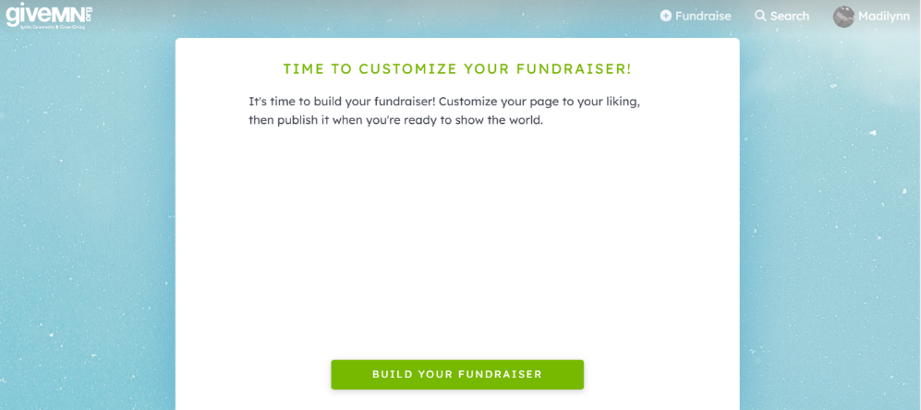
Select “Build your fundraiser”
Step 3:
Add a title! Some options to get you thinking:
“#PSGrow! Fundraiser for Project Success Institute”
“Let’s Get Cooking! Fundraiser for PS Institute”
“Certified Goals – Fundraiser for the PS Institute”
“#PSGrow – Emily’s Fundraiser for Project Success”
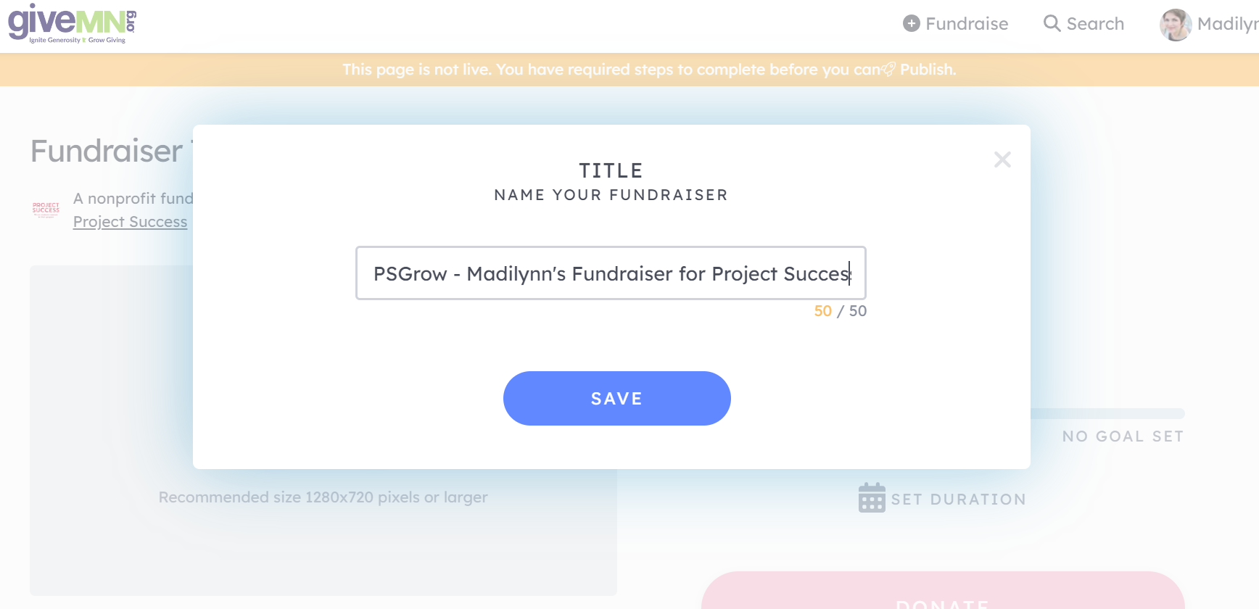
Step 3:
Write your story! Share how you are connected to Project Success and why (in your eyes) the PS Institute is a meaningful space for learning and growth. Add a bit of context about the Institute. Then close with your goal and an ask. Section below is about 200 words!
“Join me in supporting Project Success for Give to the Max Day this year! I serve as a board member (committee member, work for, volunteer at, etc.) for Project Success because _______________. I’m proud to support Project Success and their efforts in the Institute, a space where students engage in hands-on learning in topics that aren’t offered in their schools but are meaningful to their lives and wellness.
Current courses include Computer Coding, Cooking, Personal Finance, and Bike Tech. Since it’s inception in 2018, more than 500 students have earned 830 certificates. The Institute is in session for 30 weeks a year and demand is growing! PS is seeking to expand our resources to increase certificate options, including adding multiple levels for courses and expanding our offerings to include subjects such as entrepreneurship, media, arts, cyber security, and real estate through community partnerships.
Project Success is looking to raise $25,000 on Give to the Max Day to keep the PS Institute open and thriving for students who need it today and in the future. My personal fundraising goal is $#. I’ve been connected to Project Success for # years and I’m confident that my talent/time/treasure impacts the lives of young people in my community. Please join me in supporting this incredible organization by making a gift today!”
Consider adding an additional photo to this section! They add a nice personal touch to the fundraising pages! Please use a photo from the folder that accompanies these instructions, OR a photo of you in a Project Success shirt at an event.

Step 4:
Set your goal! Click on the Fundraising “thermometer” in the upper right section of the page to set your goal.
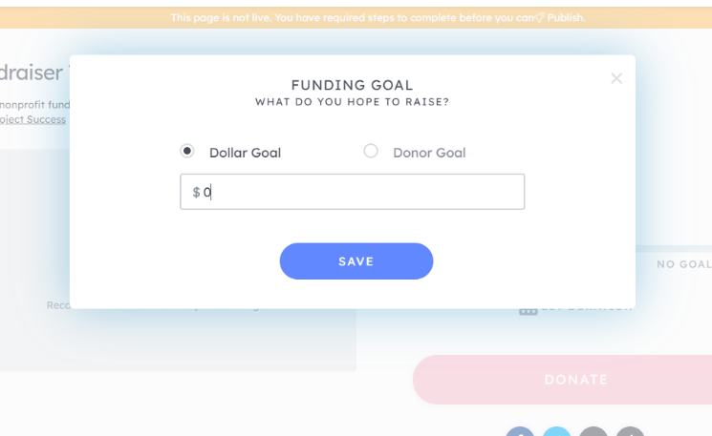
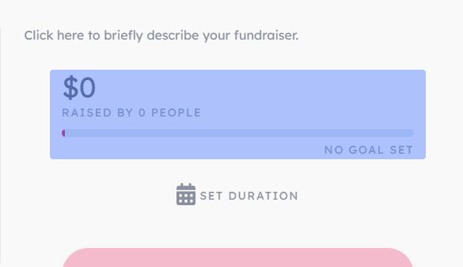

Step 5:
Set duration of your fundraiser.
Set your start date for today and your end date for November 18. (GTMD is November 17, but we want those folks who are late to the party to still support you!)
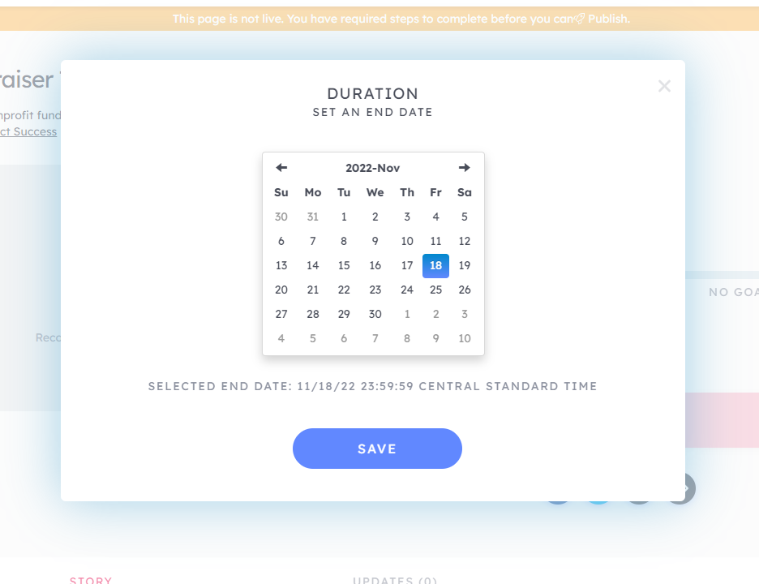

Step 6:
Add photos! In addition to this document, I’ve sent a zip folder of photos to choose from. These photos were selected by our Development and Communications team for this event. Please use these high-quality photos rather than pulling photos from our website, or elsewhere. They get compressed in the transfer process and turn out blurry! If there’s a photo you love that isn’t in the “photos to use” folder, please let me know and I’ll do my best to track it down.

Step 7:
Publish your page! You are now ready to publish your page and share it with your network! Consider sending your page to friends and family via email or posting on social media. It’s fun to post updates on your fundraising goal on Give to the Max Day! Donors get excited about “closing a gap” so let people know when you are close to hitting your goal!

Other tips:
- Posting updates on your page. This can only be done after your fundraiser is published. Consider an update to thank your first donor, when you hit your halfway point, when you are really close to your goal, and when you hit your goal!
- Celebrate all donation amounts. Whether someone gave $5 or $500, we are grateful for their support of our mission. Each donor will receive a thank you call from a PS staff member. A personal message from you on the day-of their gift is extra meaningful! A text, phone call, or email is great – however you typically communicate with this connection is great.
- After GTMD, you will receive a spreadsheet of the folks who donated to your page. Please let us know if you’d like to send them a handwritten card after the event – we are happy to provide PS stationary for you if you’d like.

